**Room Population counter “Report”**

* **Project description :**

Room population counter is a device that counts the people entering or leaving a certain room using a simple components and connections between them.

* **The aim of the project :**

Is to make the desired project with a cheap components and to maintain high quality

* **Used components :**

1. 2x Ultrasonic sensors

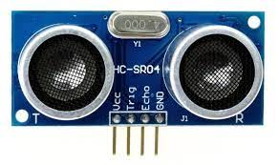

1. Raspberry pi

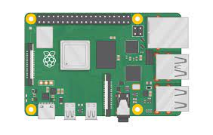

1. Esp node mcu 8266

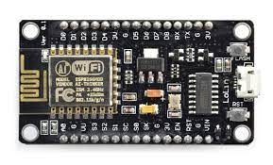

1. Tcp/Ip protocols
2. Thinkspeak (MQTT)

* **Circuit connection**

